Student Learning Objectives

* Using LINQ

**There are 8 print screens each worth 12.5%**

**Project #1**

Copy and paste the data into a notepad and label it as **Justices**

Samuel,Alito,George W. Bush,NJ,2006,0

Henry,Baldwin,Andrew Jackson,PA,1830,1844

Determine the first two lines of the new file created by the code

**#1 print screen output with code below here**

**Project #2**

**#2 print screen output with code below here**

Private Sub Button2_Click(sender As Object, e As EventArgs) Handles Button2.Click

Dim query = From line In IO.File.ReadAllLines("Justices.txt")

Let data = line.Split(",")

Let firstname = data(0)

Let Lastname = data(1)

Let fullname = (firstname & "," & Lastname).ToUpper

Let yrAppointed = CInt(data(4))

Select fullname & " was appointed in " & yrAppointed

IO.File.WriteAllLines("Just.txt", query)

MessageBox.Show("Data Transfered")

End Sub

**Project #3**

**#3 print screen output with code below here**

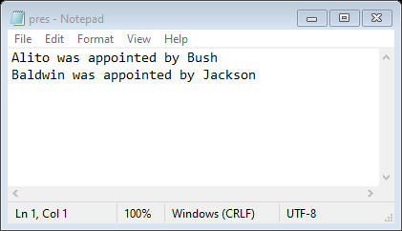

Private Sub Button3_Click(sender As Object, e As EventArgs) Handles Button3.Click

Dim query = From line In IO.File.ReadAllLines("Justices.txt")

Let lastNAme = line.Split(",")(1)

Let pres = line.Split(",")(2)

Let presLastName = pres.Split(" ").Last

Let phrase = lastNAme & " was appointed by " & presLastName

Select phrase

IO.File.WriteAllLines("pres.txt", query)

MessageBox.Show("Done")

End Sub

**Project #4**

**#4 print screen output with code below here**

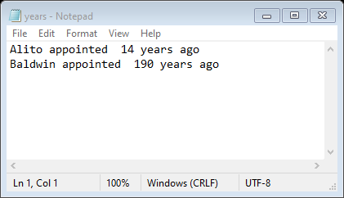

Private Sub Button4_Click(sender As Object, e As EventArgs) Handles Button4.Click

Dim query = From line In IO.File.ReadAllLines("Justices.txt")

Let lastNAme = line.Split(",")(1)

Let yrAppointed = CInt(line.Split(",")(4))

Let years = Today.Year - yrAppointed

Let phrase = lastNAme & " appointed " & years & " years ago"

Select phrase

IO.File.WriteAllLines("years.txt", query)

MessageBox.Show("Done")

End Sub

**Project #5**

**#5 print screen output with code below here**

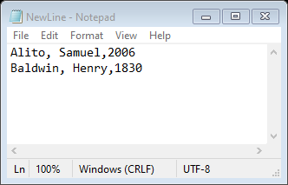

Private Sub Button5_Click(sender As Object, e As EventArgs) Handles Button5.Click

Dim query = From line In IO.File.ReadAllLines("Justices.txt")

Let data = line.Split(",")

Let firstname = data(0)

Let Lastname = data(1)

Let yrAppointed = CInt(data(4))

Let newLine = Lastname & ", " & firstname & "," & yrAppointed

Select newLine

IO.File.WriteAllLines("NewLine.txt", query)

End Sub

**Project #6**

**#6 print screen output with code below here**

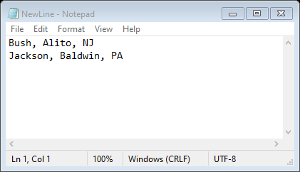

Private Sub Button6_Click(sender As Object, e As EventArgs) Handles Button6.Click

Dim query = From line In IO.File.ReadAllLines("Justices.txt")

Let data = line.Split(",")

Let lastName = data(1)

Let pres = data(2)

Let state = data(3)

Let presLastName = pres.Split(" ").Last

Let newLine = presLastName & ", " & lastName & ", " & state

Select newLine

IO.File.WriteAllLines("NewLine.txt", query)

End Sub

**Project #7**

Download the text file >> **SuperBowelWinners** from Module 9 Canvas and using LINQ display the file in a GRIDVIEW

See table for column names. Using LINQ display all data in a grid view

|  |  |  |  |  |
| --- | --- | --- | --- | --- |
| **Year** | **Team Name 1** | **Team Name 2** | **Final Score** | **Location** |
|  |  |  |  |  |
|  |  |  |  |  |

**#7 print screen output with code below here**

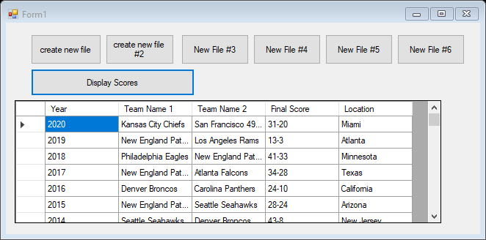

Private Sub Button7_Click(sender As Object, e As EventArgs) Handles Button7.Click

Dim games() As String = IO.File.ReadAllLines("SuperBowelWinners.txt")

Dim query = From line In games

Let data = line.Split(",")

Let year = data(0)

Let teamName = data(2)

Let teamName2 = data(3)

Let finalScore = data(4)

Let location = data(5)

Select year, teamName, teamName2, finalScore, location

DataGridView1.DataSource = query.ToList

DataGridView1.Columns("year").HeaderText = "Year"

DataGridView1.Columns("teamName").HeaderText = "Team Name 1"

DataGridView1.Columns("teamName2").HeaderText = "Team Name 2"

DataGridView1.Columns("finalScore").HeaderText = "Final Score"

DataGridView1.Columns("location").HeaderText = "Location"

End Sub

**Project #8**

Continuing from project #8 display all data where Team Name 1 equals Los Angeles Raiders in a grid view.

**#8 print screen output with code below here**

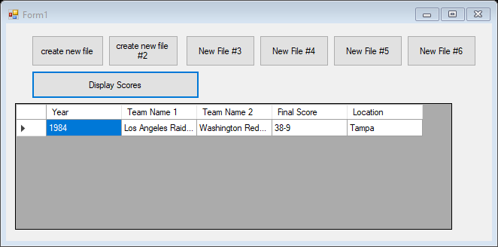

Private Sub Button7_Click(sender As Object, e As EventArgs) Handles Button7.Click

Dim games() As String = IO.File.ReadAllLines("SuperBowelWinners.txt")

Dim query = From line In games

Let data = line.Split(",")

Let year = data(0)

Let teamName = data(2)

Let teamName2 = data(3)

Let finalScore = data(4)

Let location = data(5)

Where teamName.Equals("Los Angeles Raiders")

Select year, teamName, teamName2, finalScore, location

DataGridView1.DataSource = query.ToList

DataGridView1.Columns("year").HeaderText = "Year"

DataGridView1.Columns("teamName").HeaderText = "Team Name 1"

DataGridView1.Columns("teamName2").HeaderText = "Team Name 2"

DataGridView1.Columns("finalScore").HeaderText = "Final Score"

DataGridView1.Columns("location").HeaderText = "Location"

End Sub

**Submit this document to Module 9 homework**